Tenda MW5-How to check the node devices are connected with?

Step 1: Tap “Connected Devices”

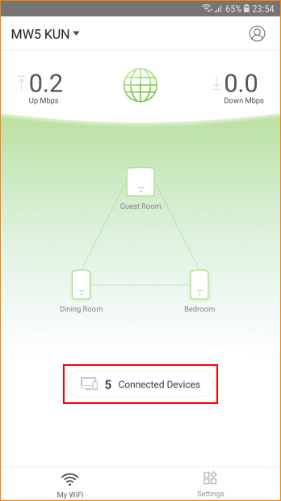

Step 2: Tap the device you want to check. E.g: Yein
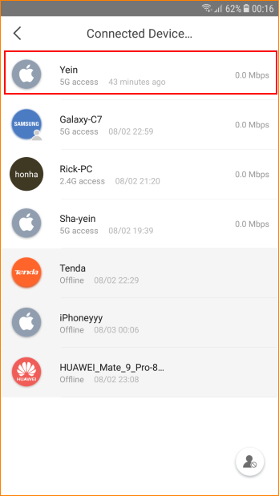

Step 3: Tap “Details”
